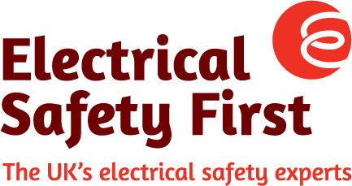
6th May 2020

SCOTLAND’S ‘ONE-STOP SHOP’ FOR PRODUCT RECALLS

Commenting on the passage of the Consumer Scotland Bill in the Scottish Parliament, Lesley Rudd, Chief Executive of Electrical Safety First, said:
“The Charity warmly welcomes the new amendment to the Bill, which requires Consumer Scotland to establish and operate a central, major product recall database, for consumers.
“Electricity is the primary cause of domestic fires in Scotland – with most of these arising from electrical products. So Electrical Safety First has long advocated the creation of such an essential resource. Recent high profile recalls and electrical fires – and the historically low success rate of recalls - have highlighted concerns around electrical risk. And the development of a consumer-focused, central recall database is timely.
“Only last week, Whirlpool announced a further 21 models – up to 55,000 machines - had been added to its recall notice for Hotpoint and Indesit washing machines. The recall was originally issued in December 2019, yet this is the second time further defective models have been discovered after publication of the original list. And last year alone, white goods (such as washing machines, fridges and tumble-dryers), caused a fire in a Scottish home on an almost-daily basis.
“It is difficult for manufacturers and retailers to trace consumers who have a recalled item if it hasn’t been registered. Yet our research found that only a third of Scottish consumers register their electrical appliances. Having a central body – a trusted, one-stop-shop for product recalls, providing essential information and advice - is key to improving consumer awareness of recalls and the need for product registration.
“We look forward to working closely with Consumer Scotland where our expertise can help identify and prioritise significant electrical safety issues, particularly in relation to white goods and fake electricals sold via online marketplaces. We also want to extend our thanks to Jackie Baillie MSP, who campaigned for and tabled this amendment. Jackie and the Scottish Parliament have taken positive and vital action to reduce the potentially lethal harm that can be caused by defective or faulty goods.”
“In the meantime, we provide advice and information on recalls on our website. Simply visit www.electricalsafetyfirst.org.uk. Or find out more about the safety of your white goods at www.whitegoodsafety.com.”

